# Orchestration tools:

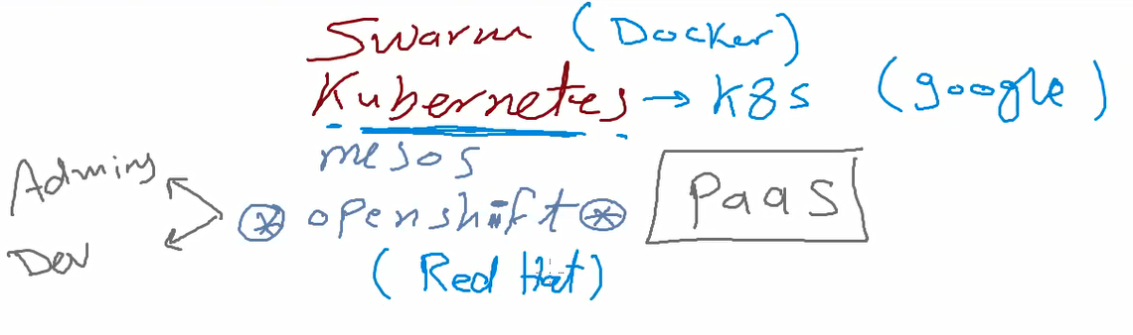

Swarm 🡪 docker company built in orchestration tool, work only with docker container engine.

Kubernetes k8s 🡪 google company, work with all container engine tools.

Openshift 🡪 work with all container engine tools.

Mesos🡪 work with all container engine tools.

K8s is orchestration tool that we use to manage docker engines to provide.

all devices combined together to create cluster the orchestration tools use this cluster as one device

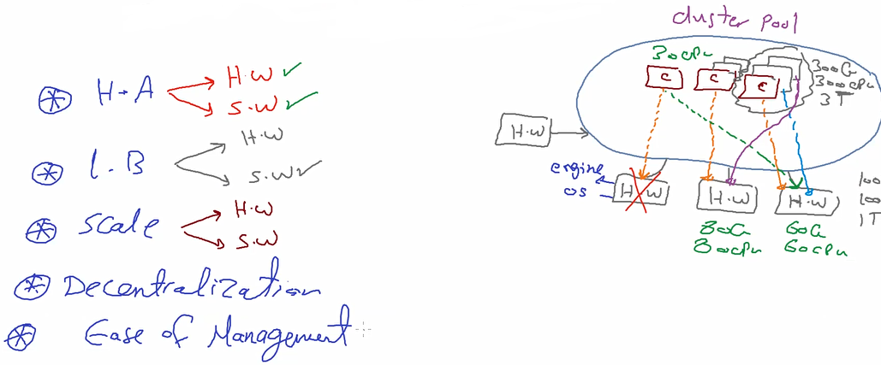

1. High availabitiy SW and HW : SW or hardware failure ll not be a big problem orchestration tool can manage and keep the containers (application) available , if one device fail , all containers ll be moved to another device in the cluster

بيعمل كلاستر من كل الاجهزه الى عنده و أي جهاز منه وقع يعرف ينقل الكونتنر على أي جهاز تانى فيهم و لو السوفتوير وقع على واحد فيهم نفس الكلام

1. Load balance : when we get a request the orchestration tool control all cluster devices and distribute the tasks between all devices

الاجهزه الى ف الكلاستر ده بنقسم الشغل عليهم بالتساوي

1. Scalability SW/HW :increase /decrease pods (SW) , and devices to scale the cluster size

ينفع نزود الاجهزه الى جوه الكلاستر و ينفع نزود الكونتينرز الى شغاله بتستقبل الطلبات بس

لازم حجم الهاردوير يكون متوافق مع احتياج السوفتوير و بناء عليه اقرر ازود و لا لا

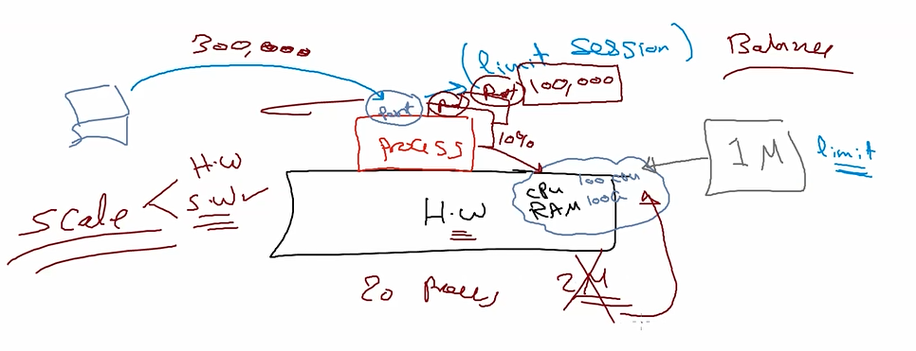

لان ده اخر الهاردوير بتاعيContainer يقدر يستقبل 100 الف ده معناه ان أخرى اعمل 10 Container الهاردوير يقدر يستقبل مليون و ال

1. Decentralization مش معتمد لا على هاردوير و لا كونتينر

سهل اتنقل على السيرفر المتاح و سهل انقل لكونتينر شغال

# K8s tools

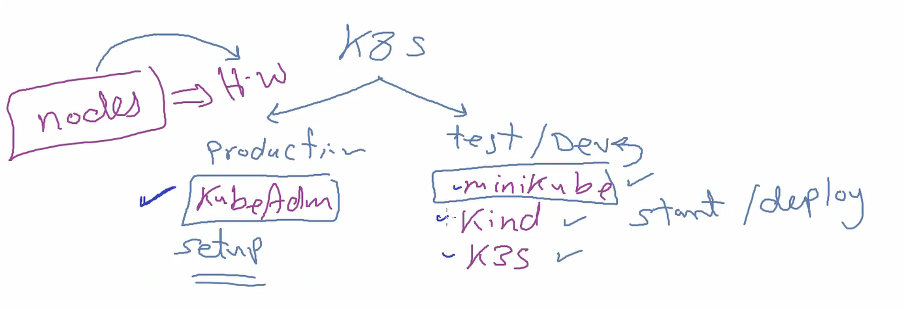for production we need to use kubeAdm and install all needed components manually

For dev/test we can use minikubes ,kind,k3s ready tools to use kubernets with simple installations

# K8s Hardware Infrastructure prospective:

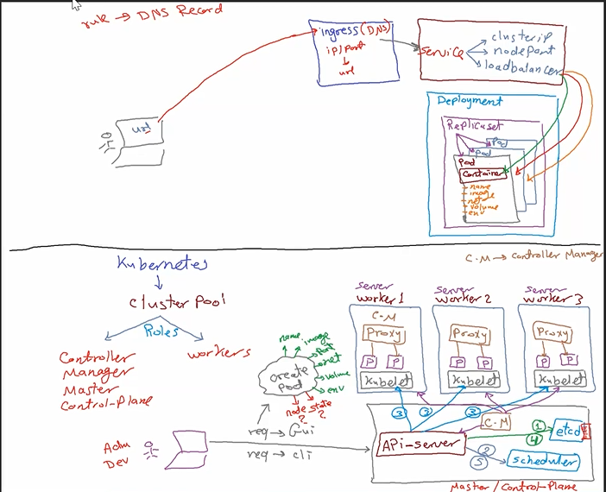

K8s tool creates cluster pool this cluster contains hw nodes , each node installed on it container engine

And k8s orchestrate the tasks executed in this container engines.

Cluster pool roles

1. Controller (manager)(master)(control-plane) one or more device (recommended more than one)

This manager contains k8s engine (platform) creates the cluster and manage all engines

1. Worker nodes : nodes (servers ) contains ours containers الاااااف الاجهزه

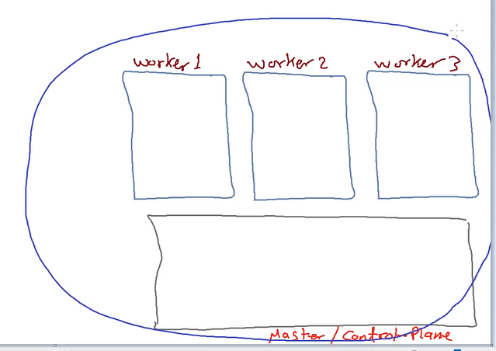

Note:

All these nodes are physical devices and communicate together to create one logical cluster pool

Master: create the cluster , create pods ,assign pods to HW nodes, and if any HW fail master reassign the task to another worker

***Request journey:***

* Admin or developer send request to master node 🡪 Req go to API-Server

API-Server is the gateway of the master responsible for :

-accept all requests

-communicate with other objects to do the user request

-assign the task to one of the workers

* API-server call etcd : db contains all data of pods (meta data) key, value (unstructured data)

So API server save all pod data in etcd except (hw node , status) because this data not yet ready it save (img , pod name , ports , network ,volume ,env variables,…)

* api-server go to scheduler : scheduler is an object that check for the more suitable node to run the pod on it , this decision depends on :
* conditions depend on process type ex:) graphic requests need special graphics card (node 1)
* available resources 🡪 but we don’t want to reach 100% usage in any node
* if no conditions and all available resources are almost the same 🡪 no. of process on each node (the less no. process node is the best choice node)
* api-server call the api-server agent (Kubelet): sw installed in each node act as api-server agent to be able to manage the worker , this kubelet is responsible for create containers and communicate direct with docker (any containerization tool)
* api-server update etcd to update the missing data (state , worker node)
* api-server update scheduler to update the usability for the worker node after creating the pod
* pods needs to communicate with each other they can use Proxy : this object responsible for pods networking (create virtual network for each pod ,create virtual nic ,assign virtual nic to pod, ip , routing between pods in the whole cluster)

note:k8s applies SDN (software define networking)🡪 R&D

* controller manager :master node object responsible for monitor and manage the available kubelets any one fails , the controller manager notify api-server so api-server go to etcd and get all this node pods to be moved to another working node after check the scheduler to find suitable available workers

# K8s from software prospective:

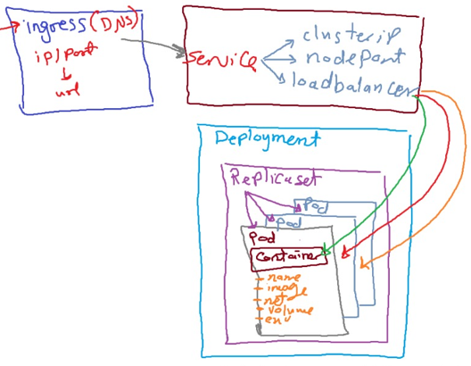

Main container problem :

Container is isolated env has (name,Container image ,port , network, volume,env variables ,..) meta date

The main problem in container is that it’s meta data is **inside** the container

So once the container deleted , its meta data also deleted , that’s why the engine couldn’t recreate the container if it deleted

K8s fixs this problem 🡪 if the container deleted it can be recreated in the same sec by removing the meta data from the container and add this data to the pod

**Pod**: (process of deployment)Object contains the container and the meta data بيفضل معلومات الكونتينر عن الكونتينر نفسه و بيطلعها بره عشان etcdلو اتمسح يعمل واحد زيه طبق الأصل و حطيت البيانات ده كلها ف ال

So Pod is  the smallest deployable units of computing that you can create and manage in Kubernetes hosts one or more containers and keep it’s metadata in etcd so for any reason the container deleted the pod be able to recreate again by the replicaset

**Replicaset:** k8s objectresponsible for no. of pods monitoring, report and recreate down pods

To keep no of pods are all up and running دورها تحافظ على العدد الى الدبلويمنت قالتهولها

**Deployment**: k8s object responsible for

* -the replicasets and its pods
* -increase /decrease no. pods
* -restart /stop pods
* -uplay any updates in pods

User couldn’t access the pod because if the pod recreated its IP ll be change

**Service:** k8s object responsible for accessing between pods and between user and pods

مسؤله توصل اليوزر للبود

Services types:

* -cluster ip : في حاله عايز البودز تتكلم مع بعض جوه الكلاستر
* -load port في حاله لو انا مش عندى غير سنجل بود لانها بتوزع عشوائي و عايز اليوزر يوصل للبود :
* -load balances في حاله عايز أوصل اليوزر بالبود لو عندى اكتر من بود و عايز اوزع الشغل عليهم :

The user needs to know Pod IP and port to connect to the pod But its not acceptable approach

So I need an easy way to provide URL to the user

**Ingress**: K8s Object act like DNS for the pod contains IP and port and URL

The user call the URL and the ingress get the Pod Ip and port to redirect to the right pod

All this objects (pod,replica,deployment,services) called Resources

All this resources are process

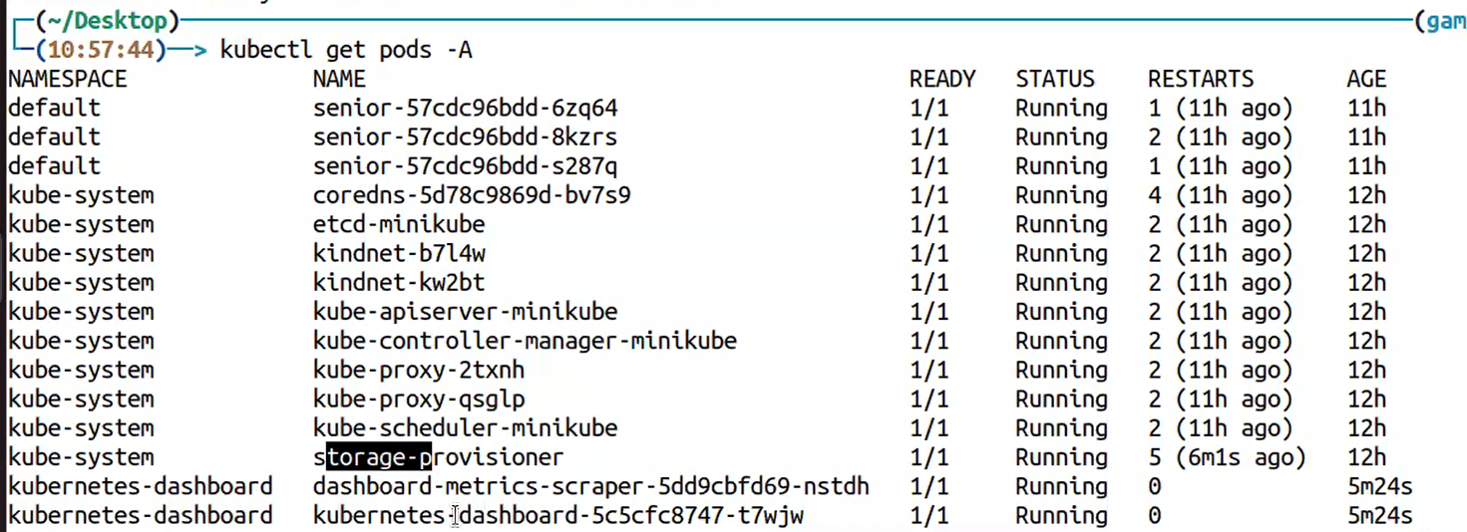

All object has image and all object has pod and replica to provide the most stable sw and avail scalability

***To activate autocomplete in kubernetes terminal:***

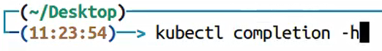

For macOs

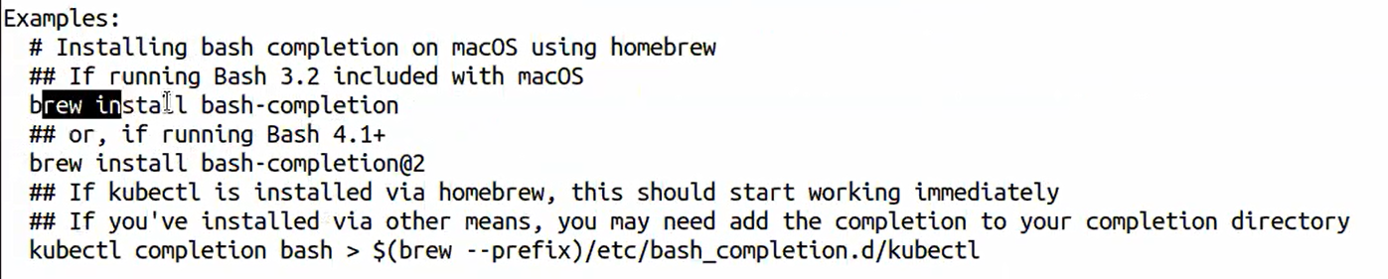

For linux

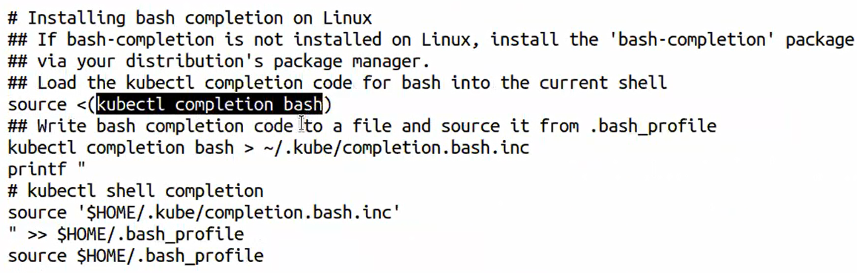

# Lap setup

To use any orchestration tool we must install any container engine first

<https://github.com/Gamal-Mohammad/instructions/blob/main/MiniKube%20Ubuntu_Debian_docker_driver>

**Install Kubernetes on Ubuntu/Debian**

#### Install Docker First if Installed Skip these steps

sudo apt update

sudo apt install curl

sudo curl -fsSL https://download.docker.com/linux/ubuntu/gpg | sudo gpg --dearmor -o /etc/apt/trusted.gpg.d/docker.gpg

sudo add-apt-repository "deb [arch=$(dpkg --print-architecture)] https://download.docker.com/linux/ubuntu $(lsb_release -cs) stable"

sudo apt update

sudo apt -y install docker-ce docker-ce-cli containerd.io docker-compose-plugin docker-registry

sudo usermod -aG docker $USER

newgrp docker

**######### Install MiniKube (kubernetes platform)**

curl -LO <https://storage.googleapis.com/minikube/releases/latest/minikube_latest_amd64.deb> (download debian pkg)

sudo dpkg -i minikube_latest_amd64.deb (install minikube)

minikube start --driver=docker --nodes=2(start minikube and use my container engine)

sudo snap install kubectl –classic (install command line instead of use minikube kubectl – any command)

minikube kubectl -- get pods = kubectl get pods

minikube kubectl -- cluster-info = kubectl cluster-info

kubectl cluster-info

minikube addons list

minikube dashboard &

kubectl get nodes

kubectl get pods -A

# Manage K8s :

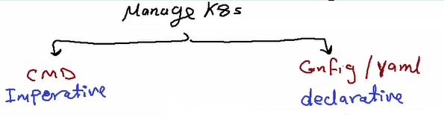

# 1-Kubernates commands (CMD):

|  |  |
| --- | --- |
| Minicube status | Get no. nodes in minikube |
| Kubectl get nodes | Get k8s nods |
| Kubectl get pods == docker ps -a | List pods |
| Kubectl get deployment | List deployment |
| Kubectl get replicasets | List replicas |
| Kubectl create deployment senior –img https –replicas 3 | Create deployment with name senior |
| Kubectl describe pod senior-7586556579-althj | Get more details about the pod ----- |
| Kubectl scale deployemt senior –relicas 6 | Set replicas = 6 in senior deployment |

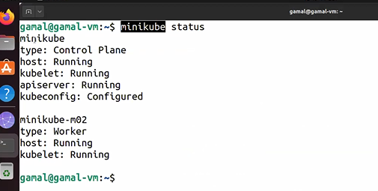

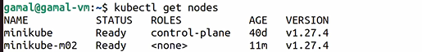

If I want to increase nodes it depends on vm available resources

I can reserve resources for each node otherwise it ll be as default (1 cpu , 2GB ram)

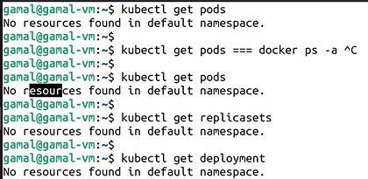

**Kubectl create deployment senior –img https –replicas 3**

When we create deployment that means it ll create implicitly replica and pods

I only need to mention the image of the containers I need to use in the pods and no. replicas

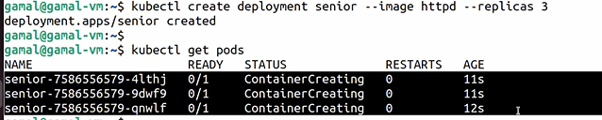

Name of pods consist of:

Senior 🡪 deployment name

7586….. 🡪 pod name

4lthj🡪 container name

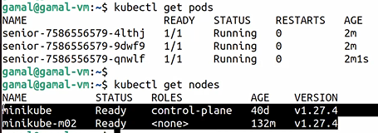

To know more details of pods use -o wide

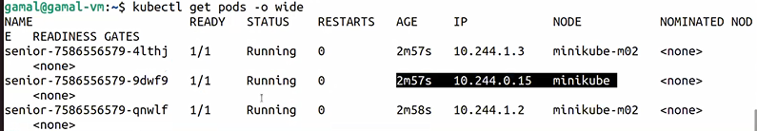

To know more details about the pod we can use describe

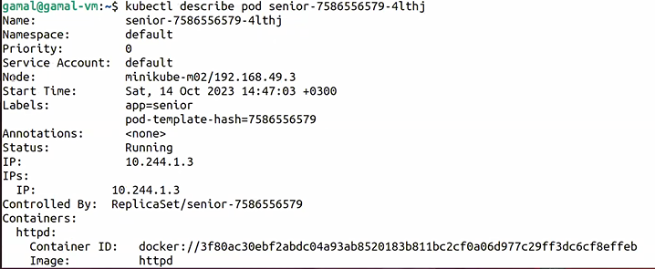

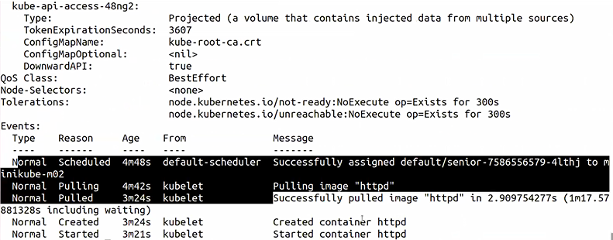

The progress is appear here the scheduler assign the pod to the worker node

The kubelet pull the img

The kubelet create the container

The kubelet start the container



If we delete the pod



The replica save the no of pods and recreate it again



Replicaset عملت واحد تانى بدل الي اتمسح



If I want to increase no of pods 🡪 scale the senior deployment

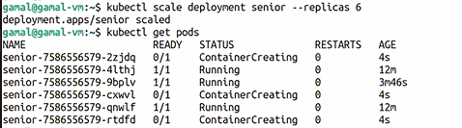

After scaling the replica increase no of pods to be 6

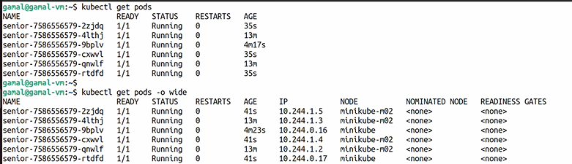

We need to restart minikube if the vm restarted

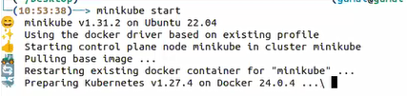

Without it connection ll refuse or time out

Use dashboard : minikube dashboard &  
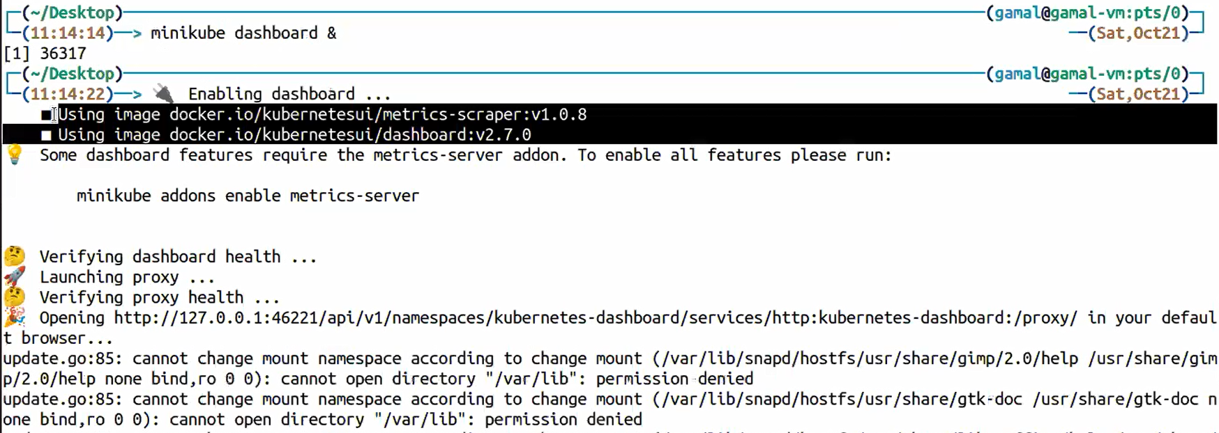

This ll open gui on browser and present all resources and all actions we need to do in this resources :

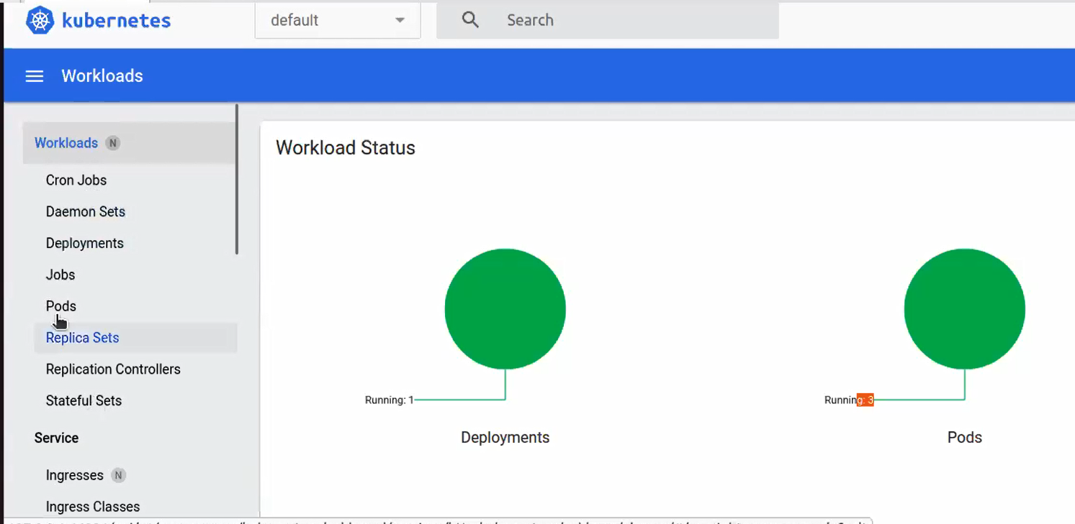

And all actions in pods : log , exec ,delete , edit

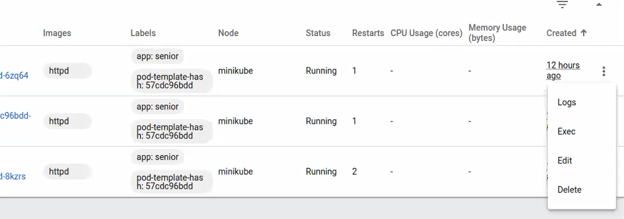

Exec open terminal and execute the commands in the container

We select delete the pod so the replicaset ll create another pod in the same sec

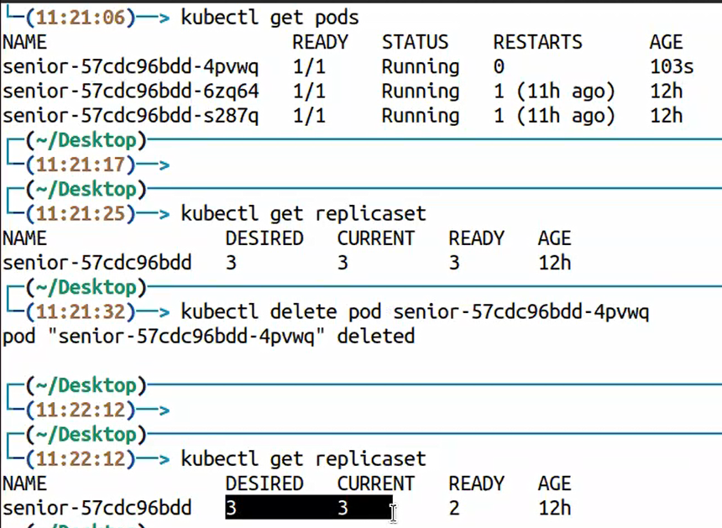

After one second ready become 3 because replica recreate the deleted pod

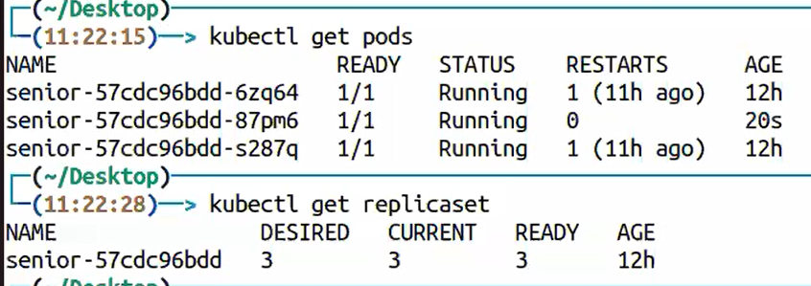

# 2-Yaml file (declarative)

1. write file from scratch
2. use kubectl to write file get the input and convert it to yml format
3. use vscode to write file using plugin or k8s yml generator using web interface

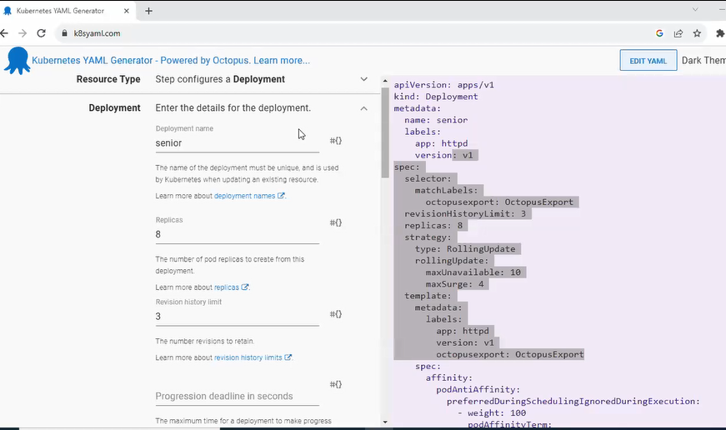

# Yml File components:

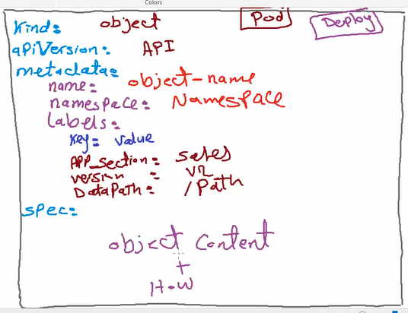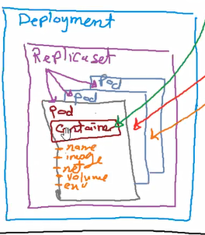

-kind : object name (pod , replicaset, deployment,…)

-apiVersion: v1 ,v2

-metadata : contains

* Name:deployment name
* Namespce : if one name space add it in name scpace if more than one remove it from the config file Just duplicate the process in the two namespaces
* Label : used in (selector , scalling ,service , endpoint creation )key and value descript the object

-specs:

All internal objects and HW resources ex: deployment specs are (replicas, pods,containers ,and HW)

Lab 1: write config file for stand alone pod from scratch

-mkdir k8s 🡪 cd k8s

-vim pod-lab1.yml

و هكذا replica نبتدى اسمه بكمه Replica يفضل لو خنعمل فايل للبود نبتدى بكلمه بود و لو هنعمل فايل ل

* 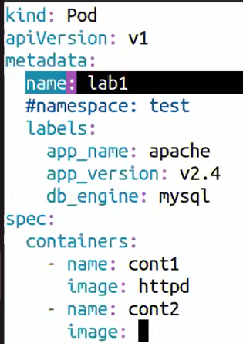
* Specs could contain one or more container and HW resources

Lab2: use kubectl tool to create config file for http container in stand alone pod

Kubectl run lab2 –image httpd 🡪 this command ll create the pod

-o yml 🡪 write the file in yml format

- --dry-run=client 🡪 don’t run only create the config file

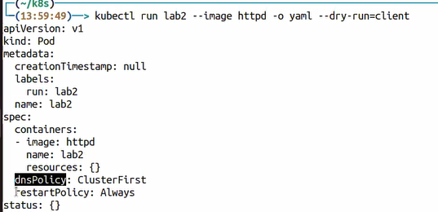

-timestamp = null means that this command didn’t created yet

Lab3: Deployment config file

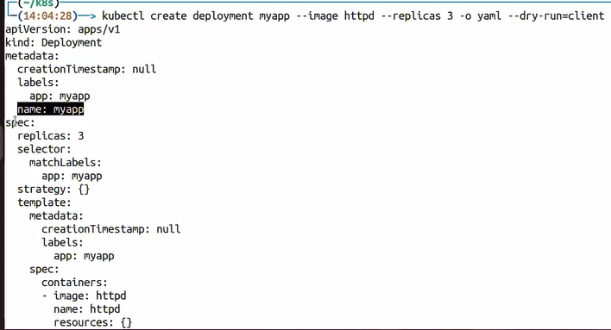

Lab4: use k8syml.com to create deployment config file

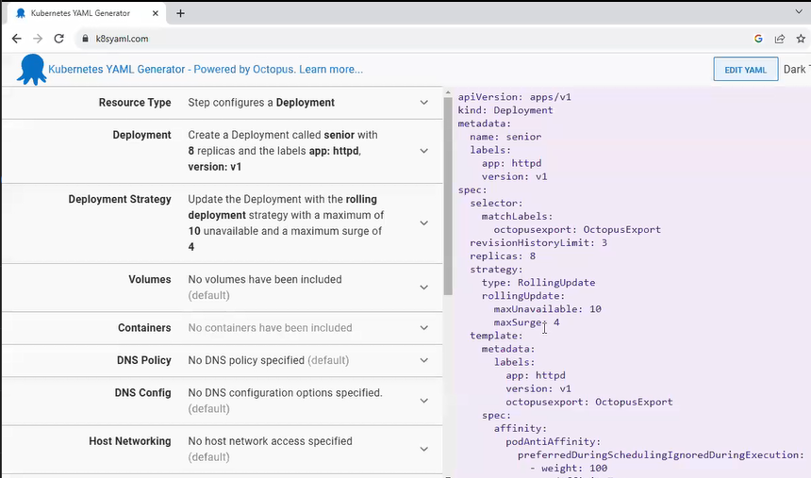

-vim deployment-lab4.yml 🡪 copy the yml and paste it to the file

# Apply the config file :

If I write the command I ll use kubectl run … and kubectl create….

But in this case I ll use the configuration file 🡪 I ll use kubectl apply -f (file) pod-lb1.yml

